Curcumin-95: India’s Golden Export for Health, Healing, and Global Wellness
Meta Description: Discover how Curcumin-95, a 95% pure curcuminoid extract from Indian turmeric, delivers powerful antioxidant and anti-inflammatory benefits. Learn its uses, recipes, and why global buyers trust Indian exporters.

🌿 Introduction: The Golden Essence of India
From the heart of India’s turmeric fields arises Curcumin-95, a highly concentrated extract standardized to contain 95% curcuminoids—the bioactive compounds responsible for turmeric’s therapeutic power. Known globally for its anti-inflammatory and antioxidant effects, Curcumin-95 is revolutionizing natural health supplements, functional foods, and cosmetics.
At [Your Company Name], we are a trusted herbal export company from India, providing premium Curcumin-95 Extract that meets global purity and safety standards. With advanced extraction, hygienic processing, and ISO/GMP-certified manufacturing, our turmeric extracts serve international nutraceutical and cosmetic brands worldwide.


Caption: Curcumin-95 extract — India’s globally trusted antioxidant and wellness enhancer.

🔬 Technical Specifications of Curcumin-95
Parameter | Specification
Product | Turmeric Extract 95%
Botanical Name | Curcuma longa
Part Used | Rhizomes
Form | Fine Powder
Color | Yellowish Orange
Purity | 100%
Total Curcuminoids | NLT 95% (by UV / HPLC)
Odor | Characteristic
Taste | Characteristic
Particle Size | NLT 90% through 120 mesh
Bulk Density | 0.4 g/ml
Moisture | NMT 0.8%
pH | 5–7
Ash Content | NMT 5%
Residual Solvent | NMT 5000 ppm
Microbial Load | <1000 cfu/g
Shelf Life | 1–2 Years
Packaging | 25 kg HDPE Drum with double poly liner
Origin | Made in India

⚗️ Extraction & Purity
Our Curcumin Extract (Three Peak – Nature Grade) is developed under controlled, sanitized environments using solvent-free extraction. Each batch undergoes UV spectrophotometric testing and HPLC validation to ensure curcuminoid consistency and contaminant-free quality.
We make thorough microbiological and chemical checks before final release, ensuring the extract is ideal for nutraceuticals, pharmaceuticals, and cosmetic formulations.

🌱 Key Features
- Free from contaminants and heavy metals
- Longer shelf life (1–2 years)
- High curcuminoid content (>95%)
- Effective for inflammation, arthritis, and skin health
- Quality ingredients, hygienically processed
- Globally compliant with ISO, GMP, and FSSAI standards

💪 Health Benefits of Curcumin-95

1. Joint and Chronic Pain Relief
Curcumin’s strong anti-inflammatory action helps ease joint stiffness and swelling. It reduces markers of inflammation, making it a natural aid for arthritis and chronic pain.

2. Cardiovascular Support
Curcumin supports healthy cholesterol levels and prevents LDL oxidation. Its antioxidant effect improves blood vessel function and helps maintain heart health.

3. Digestive Wellness
Curcumin stimulates bile secretion, improving fat digestion and overall metabolic balance. It’s particularly beneficial for gastric discomfort and liver detoxification.

4. Liver Protection
As a hepatoprotective compound, Curcumin-95 assists in detoxifying enzymes, protecting the liver from toxins, alcohol, and environmental stressors.

5. Immunity and Antioxidant Boost
With an ORAC value exceeding most herbs, Curcumin neutralizes free radicals and enhances immune cell performance, making it a natural anti-aging and immune-enhancing compound.

6. Weight Management
Curcumin regulates fat metabolism, reduces adipose inflammation, and supports healthy insulin sensitivity—ideal for controlling obesity.

7. Skin Health and Beauty
Used in topical creams and masks, Curcumin-95 reduces pigmentation, acne, and dullness, while enhancing skin radiance through its anti-microbial and antioxidant properties.
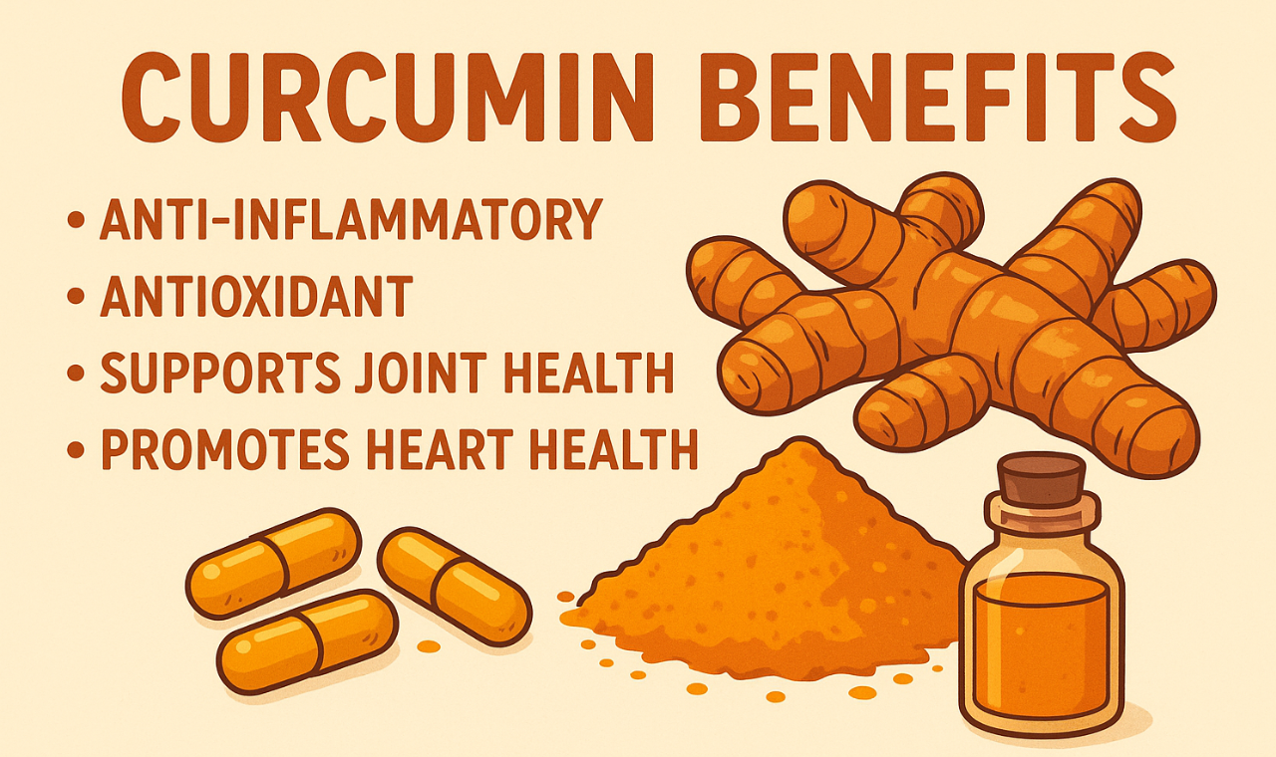
Caption: Curcumin benefits

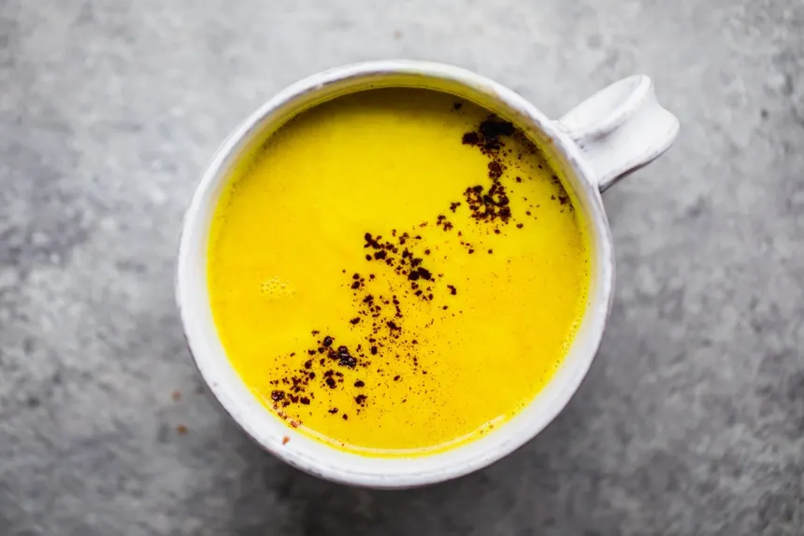
Caption: Curcumin-95 in daily life—infuse wellness into your diet through lattes, smoothies, and meals.

🍵 Delicious Ways to Consume Curcumin-95

1. Golden Milk (Turmeric Latte)
Ingredients:
- 1 cup milk (or almond milk)
- ½ tsp Curcumin-95 extract
- Pinch of black pepper and cinnamon
- 1 tsp honey
Instructions:
Simmer ingredients together for 5 minutes. Black pepper enhances curcumin absorption—ideal for bedtime relaxation.

2. Curcumin Smoothie Bowl
Ingredients:
- 1 banana
- ½ tsp Curcumin-95 extract
- 1 cup coconut milk
- ½ tsp ginger powder
- Ice cubes
Instructions:
Blend, pour into a bowl, and top with chia seeds or mango slices.

3. Detox Turmeric Tea
Ingredients:
- 1 cup hot water
- ½ tsp Curcumin-95 extract
- Dash of lemon juice and honey
Instructions:
Mix well and sip warm each morning for detox and immunity.

4. Turmeric Rice or Curries
Add a pinch of Curcumin-95 powder while cooking rice, lentils, or soups for both flavor and health benefits.

5. Curcumin Energy Bites
Combine oats, honey, dates, and Curcumin-95 powder. Roll into small balls—perfect for on-the-go wellness snacks.

🏭 Why Source Curcumin-95 from India?
India is the world’s largest producer of turmeric, accounting for nearly 80% of global output. The Indian subcontinent’s soil, climate, and traditional cultivation practices yield roots rich in curcuminoids.

Advantages of Buying from Indian Exporters
- Standardized Extracts (95% Curcuminoids) tested by UV/HPLC.
- Export-grade packaging (25 kg HDPE drums with double poly bags).
- Customized labeling and bulk order flexibility.
- Ethically sourced from certified turmeric farms.
- Global shipping with COA, MSDS, and phytosanitary documentation.
As a leading Curcumin exporter from India, we ensure consistency, purity, and compliance with international quality norms.

🧴 Curcumin in Cosmetic and Pharmaceutical Applications
Curcumin’s multi-faceted bioactivity has expanded its use beyond food supplements into skincare and cosmeceuticals.
Applications include:
- Brightening and anti-acne formulations
- UV-protective and anti-aging creams
- Healing serums for inflammation and pigmentation
- Herbal soaps and masks
In pharmaceuticals, Curcumin is researched for roles in managing cancer, arthritis, metabolic syndrome, and neurodegenerative disorders.

🌏 Conclusion: The Golden Standard of Indian Herbal Exports
Curcumin-95 bridges traditional Ayurveda with modern scientific validation. Whether used in nutraceuticals, functional beverages, or skincare, it represents India’s legacy of purity and innovation.
Partnering with a trusted Curcumin exporter from India ensures that your brand delivers nature’s best — pure, potent, and globally compliant.

Keywords: Herbal export India, Curcumin exporter, Curcumin-95, turmeric extract 95% curcuminoids, Ayurvedic ingredients export, antioxidant supplement India.

